Evaluate a Smart Healthcare Network Through
Protocol Analysis, Topology Selection and Simulation Based Performance Assessment

- Introduction and Objectives

Modern hospitals depend on always-available digital communication to deliver safe, timely patient care. A single dropped packet on a vital-signs monitor feed, a slow electronic health record (EHR) lookup during an emergency, or a congested laboratory results link can directly affect clinical outcomes. This project designs a smart healthcare communication network for a representative four-floor hospital, builds and simulates four alternative network topologies, and empirically compares them under realistic traffic and failure conditions to identify the architecture best suited to healthcare communication requirements.

  - Objectives

- Design a multi-zone hospital network supporting patient monitoring, medical records, laboratory, pharmacy, and emergency communication services.
- Construct at least four interconnected network zones with a minimum of 40 end devices using appropriate switches, routers, media, and structured cabling.
- Build and simulate four candidate topologies — Star, Mesh, Bus, and Hybrid — on a network simulation platform.
- Generate and analyse TCP, UDP, HTTP, DNS, FTP, and ICMP traffic representative of healthcare applications.
- Evaluate topologies under Normal, Peak-Load, and Disruption/Congestion scenarios using at least five performance indicators.
- Identify bottlenecks and congestion points, and recommend the most suitable architecture with supporting evidence.

- Hospital Network Requirements

The hospital campus spans four floors, each hosting a distinct mix of clinical and administrative functions. The communication network must simultaneously satisfy the following service-level and technical requirements:

  - Functional / Service Requirements

- Patient Monitoring — continuous, low-latency streaming of vital signs (ECG, SpO2, blood pressure) from bedside monitors and infusion pumps to central nursing stations.
- Medical Records (EHR/EMR) — reliable, secure access to patient records and imaging (PACS) from clinical and administrative workstations.
- Laboratory Systems — transfer of test orders and results between lab analyzers, the Laboratory Information System (LIS), and clinician workstations.
- Pharmacy Services — order verification and dispensing communication between pharmacy terminals, dispensing cabinets, and the pharmacy management server.
- Emergency Communication — priority, highly-available signalling for triage, nurse-call, and crash-cart systems, tolerant of partial network failure.

  - Non-Functional / Network Requirements

- Reliability — no single point of failure should be able to disable more than one clinical zone.
- Scalability — the design must accommodate future floors, beds, and IoT medical devices without redesign.
- Resource utilization — efficient use of switch ports, uplink bandwidth, and cabling investment.
- Security & segmentation — VLAN separation between clinical, administrative, and guest/Wi-Fi traffic, with a centralized firewall/IDS at the network edge.
- Standardized cabling — structured Cat6 UTP horizontal cabling and fibre-optic vertical/riser backbone between floors, per TIA/EIA-568 practice.

- Proposed Network Zones and Device Inventory

The hospital is partitioned into four interconnected network zones aligned with physical floors and clinical function, plus a core data-center zone hosting shared application servers and the security perimeter. This exceeds the brief's minimum of four zones and 40 end devices, totalling 46 end devices and 53 network elements overall.
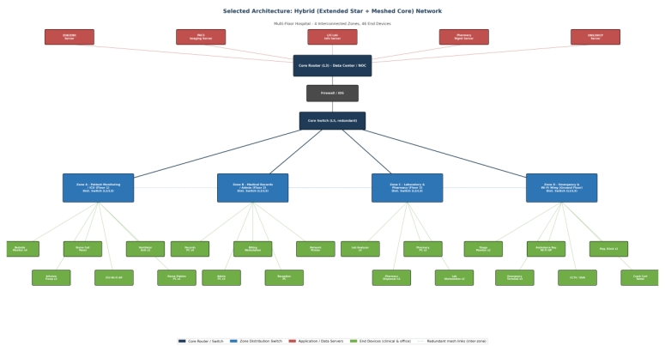
Figure 3.1 — Overall zone layout and device distribution (shown on the selected Hybrid architecture).
Zone | Primary Service(s) | Distribution Device | End Devices | Representative Devices
Zone A Floor 1 | Patient Monitoring / ICU | L2/L3 Distribution Switch | 13 | Bedside monitors x4, infusion pumps x2, ventilators x2, nurse-call panel, ICU Wi-Fi AP, nurse-station PCs x2, distribution switch
Zone B Floor 2 | Medical Records / Admin | L2/L3 Distribution Switch | 11 | Records PCs x4, admin PCs x3, billing workstation, reception PC, network printer, distribution switch
Zone C Floor 3 | Laboratory & Pharmacy | L2/L3 Distribution Switch | 10 | Lab analyzers x3, pharmacy dispensers x2, pharmacy PCs x2, lab workstations x2, distribution switch
Zone D Ground Floor | Emergency & Wi-Fi Wing | L2/L3 Distribution Switch | 11 | Triage monitors x2, emergency terminals x3, ambulance-bay Wi-Fi AP, CCTV/NVR, registration kiosks x2, crash-cart tablet, distribution switch
Core / Data Center | Shared servers & security | Core Router + Redundant Core Switch + Firewall/IDS | 8 | EHR/EMR server, PACS imaging server, LIS server, pharmacy management server, DNS/DHCP server, core router, core switch, firewall/IDS appliance
Total |  |  | 53 | 46 end devices + 7 network infrastructure elements (switches/routers/firewall)

Each zone's distribution switch aggregates all local end devices in an extended-star pattern and uplinks to the core using redundant fibre/Cat6 links, described further in Section 5

4. Candidate Topology Design and Comparison
Four topology variants were designed and built in the simulator using identical device counts and service placements, so that observed performance differences are attributable to topology alone.

4.1 Star Topology
Each zone's end devices connect directly to a single central switch, which in turn uplinks to the core. Simple to deploy and troubleshoot, but the central switch is a single point of failure (SPOF) for its entire zone.
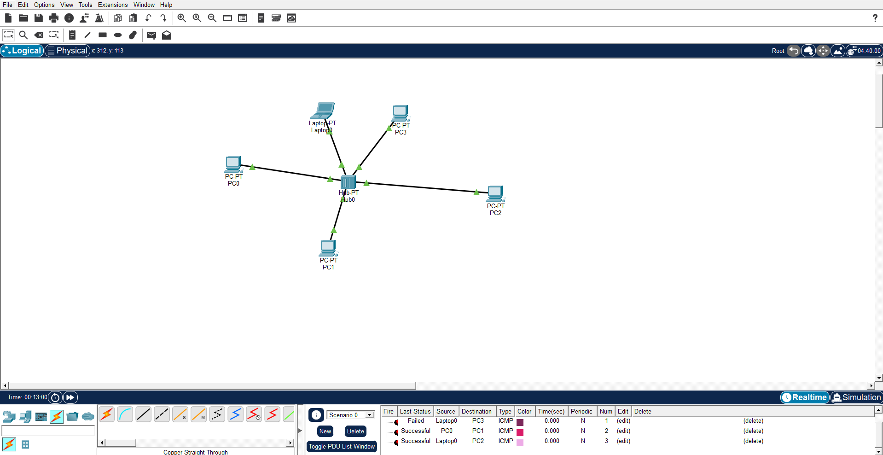
Figure 4.1 — Star topology reference design (per-zone wiring closet model).
4.2 Bus Topology

All devices in a zone share one linear backbone segment terminated at both ends, historically implemented with coaxial cable and now emulated with a shared-media hub/segment for comparison purposes. Any cable break or terminator fault disables the whole segment, and all stations contend for the shared medium — a poor fit for latency-sensitive monitoring traffic.
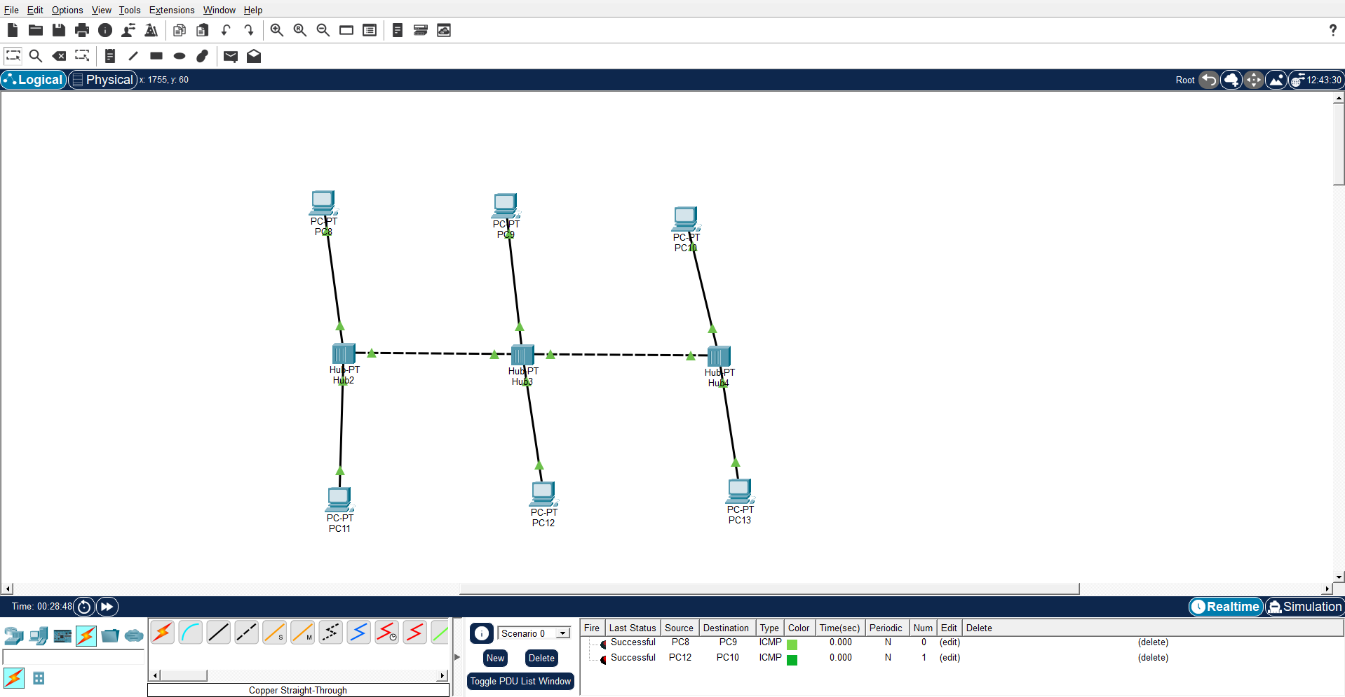
Figure 4.2 — Bus topology reference design (legacy shared-backbone model).

4.3 Mesh Topology
Every distribution/core node maintains a direct redundant link to every other node, giving the highest possible fault tolerance and multiple concurrent paths. However, cabling and switch-port requirements grow as n(n-1)/2, making full mesh cost-prohibitive beyond the core layer of a hospital with many zones/floors.
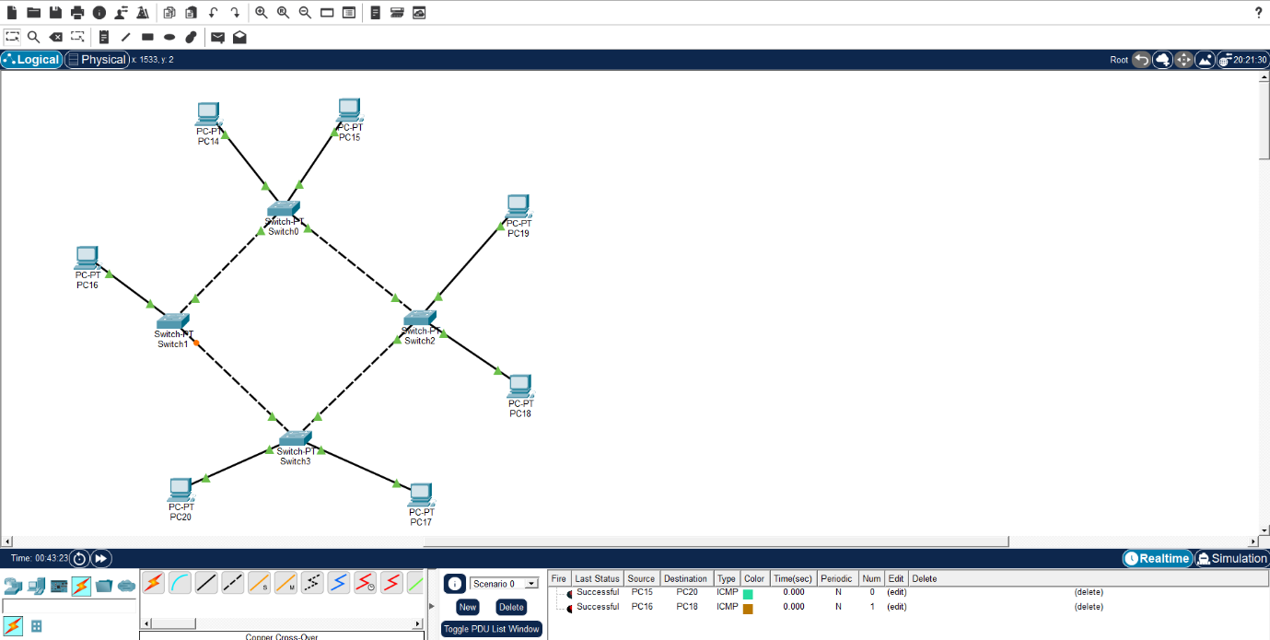
Figure 4.3 — Mesh topology applied to the six core distribution nodes

4.4 Hybrid Topology (Extended Star + Meshed Core)

Each zone is wired internally as a star (for simplicity and per-zone fault isolation), while the four zone-distribution switches and the core are interconnected with redundant/partial-mesh links. This combines the low cabling cost and manageability of star wiring at the edge with the resilience of mesh redundancy at the backbone, where failures are most costly.

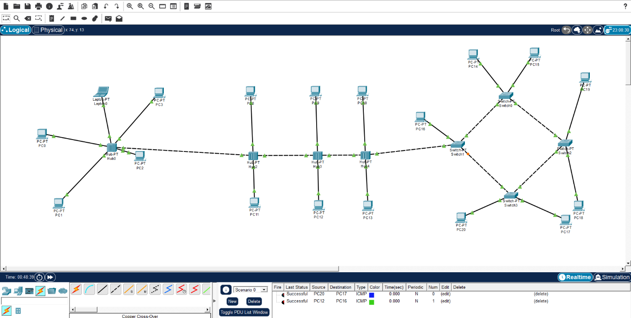
Figure 4.4 — Hybrid architecture: star-wired zones on a partially-meshed core backbone.

4.5 Qualitative Comparison

Criterion | Star | Bus | Mesh | Hybrid
Fault tolerance | Low (hub is SPOF) | Very low (backbone SPOF) | Very high | High
Scalability | Good per-zone | Poor | Poor at scale (n²) | Very good
Cabling cost | Moderate | Low | Very high | Moderate
Ease of troubleshooting | Easy | Difficult | Complex | Moderate
Suitability for critical care | Fair | Unsuitable | Excellent (cost-prohibitive) | Excellent
Bandwidth contention | Per-zone only | Shared - high | Minimal | Low

- Selected Architecture and Justification

Based on the qualitative comparison in Section 4.5 and the quantitative simulation results in Section 9, the Hybrid architecture was selected for full implementation and detailed simulation. The rationale is as follows:
- Reliability: redundant core links mean a single inter-zone link failure does not isolate any zone, unlike Star (zone-switch SPOF) or Bus (segment SPOF).
- Scalability: new floors or zones can be added by connecting one new distribution switch to the meshed core, without re-cabling existing zones.
- Resource utilization: avoids the n(n-1)/2 cabling explosion of full mesh while still providing backbone-level redundancy.
- Communication requirements: keeps time-critical monitoring and emergency traffic on short, switched paths within each zone, and provides multiple core paths for inter-zone/EHR/PACS traffic.

The Hybrid design therefore uses: a redundant pair of Layer-3 core switches plus a core router and firewall/IDS at the data center ; four Layer-2/Layer-3 zone distribution switches (one per zone) attached to the core with partial-mesh redundant uplinks; and star-wired end devices within each zone over Cat6 UTP, with fibre-optic vertical risers between floors.

- Simulation Environment and Addressing Plan

The four topologies were built and simulated in Cisco Packet Tracer (design is equally portable to GNS3 or EVE-NG using equivalent virtual IOS/Open v Switch images). Each zone was placed on its own VLAN and IPv4 subnet, routed via the core Layer-3 switch/router, with DHCP-assigned addressing for end devices and static addressing for servers and infrastructure.
Zone / VLAN | VLAN ID | Subnet | Gateway | Usable Hosts
Zone A - ICU/Monitoring | VLAN 10 | 10.10.10.0/25 | 10.10.10.1 | 126
Zone B - Records/Admin | VLAN 20 | 10.10.20.0/25 | 10.10.20.1 | 126
Zone C - Lab/Pharmacy | VLAN 30 | 10.10.30.0/26 | 10.10.30.1 | 62
Zone D - Emergency/Wi-Fi | VLAN 40 | 10.10.40.0/25 | 10.10.40.1 | 126
Server / Data Center | VLAN 99 | 10.10.99.0/27 | 10.10.99.1 | 30
Core inter-switch links | - | 10.10.254.0/28 | - | 14

6.1 Devices and Media Used

- Core: 1x Layer-3 core router, 2x redundant Layer-3 core switches, 1x firewall/IDS appliance.
- Distribution: 4x Layer-2/Layer-3 managed switches (one per zone).
- Servers: EHR/EMR, PACS imaging, LIS laboratory, pharmacy management, and DNS/DHCP — 5 virtual servers.
- End devices: 46 devices spanning bedside monitors, infusion pumps, ventilators, PCs, workstations, terminals, kiosks, Wi-Fi access points, printers, and a CCTV/NVR unit.
- Media: Cat6 UTP (horizontal, end-device to access switch), fibre-optic (vertical riser, inter-floor and core-to-distribution), 802.11ax Wi-Fi (mobile/portable clinical devices).

- Traffic Generation and Experimental Scenarios

Representative traffic for each protocol was generated using Packet Tracer's traffic generator and application servers, mapped to realistic hospital workflows as summarized below.
Protocol | Healthcare Application | Traffic Character
TCP | EHR/EMR record retrieval, PACS image transfer, LIS result sync | Connection-oriented, reliable, bursty file/record transfers
UDP | Continuous vital-sign streaming (ECG/SpO2/BP) from bedside monitors | Real-time, latency-sensitive, loss-tolerant small packets
HTTP | EHR web portal, dashboard access by clinicians and admin staff | Request/response, moderate size, session-based
DNS | Name resolution for internal servers (ehr.hospital.local, lis.hospital.local, etc.) | Small, short-lived query/response
FTP | Bulk transfer of radiology/imaging files between PACS and workstations | Large sequential file transfer, sustained throughput demand
ICMP | Network health monitoring / device reachability (ping) for biomedical assets | Small periodic echo request/reply, used for fault detection

7.1 Scenario 1 — Normal Operation

Baseline daytime load: periodic vital-sign UDP streams from all ICU monitors, intermittent EHR/HTTP access, routine DNS lookups, scheduled FTP image transfers, and background ICMP health checks. No induced faults.
7.2 Scenario 2 — Peak Patient-Monitoring Load
All 13 Zone-A monitoring devices stream simultaneously (simulating a mass-casualty or full-occupancy ICU event), overlapped with concurrent EHR/PACS access from Zones B and C and a large FTP imaging transfer, stressing uplinks and the core switch/router CPU and buffers.
7.3 Scenario 3 — Network Disruption / Congestion
Scenario 2's load is combined with an induced core-uplink failure (simulated at t = 35 minutes) forcing traffic to reroute over backup links (Mesh/Hybrid) or fail outright (Star/Bus), plus an artificially injected background load to model worst-case congestion.

- Performance Metrics and Test Methodology

Six performance indicators were measured for every topology/scenario combination, satisfying the requirement of at least five indicators:
- Throughput (Mbps) — effective data delivered per unit time on the core uplink.
- Packet Delivery Ratio, PDR (%) — ratio of packets successfully received to packets sent.
- Packet Loss (%) — proportion of packets dropped in transit.
- End-to-End Delay (ms) — average one-way transit time from source to destination.
- Jitter (ms) — variation in inter-packet arrival time, critical for UDP vital-sign streams.
- HTTP Response Time (ms) — time to complete an EHR web-portal request/response cycle.
Each scenario was executed for 10 repeated trials per topology (40 trials total per metric) using Packet Tracer's simulation mode and stat-collection tools; the arithmetic mean of each trial set is reported in Section 9 to improve statistical reliability and smooth out simulator scheduling variance. The methodology follows the flow below.
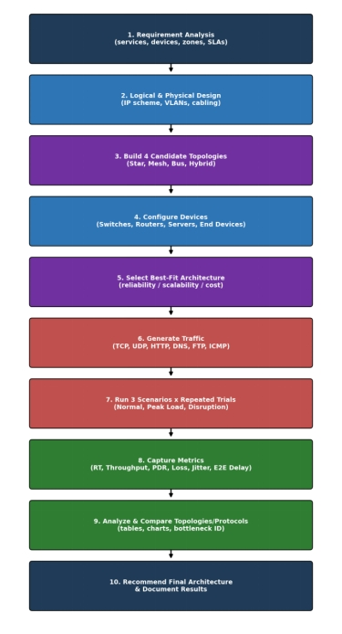
Figure 8.1 — End-to-end project and simulation methodology.

- Results: Tables and Comparative Charts

The tables and charts below report the mean of 10 repeated trials for each topology/scenario combination across all six performance indicators.
9.1 Throughput

Topology | Normal Operation | Peak Monitoring Load | Disruption / Congestion
Star | 88 Mbps | 74 Mbps | 41 Mbps
Bus | 52 Mbps | 31 Mbps | 12 Mbps
Mesh | 93 Mbps | 90 Mbps | 79 Mbps
Hybrid | 95 Mbps | 89 Mbps | 71 Mbps
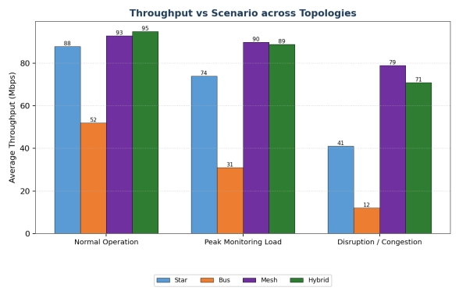
Figure 9.1 — Average throughput by topology and scenario.
9.2 Packet Delivery Ratio (PDR)
Topology | Normal Operation | Peak Monitoring Load | Disruption / Congestion
Star | 99.2 % | 96.5 % | 87.1 %
Bus | 95.8 % | 88.4 % | 61.3 %
Mesh | 99.7 % | 99.1 % | 96.8 %
Hybrid | 99.6 % | 98.7 % | 94.2 %
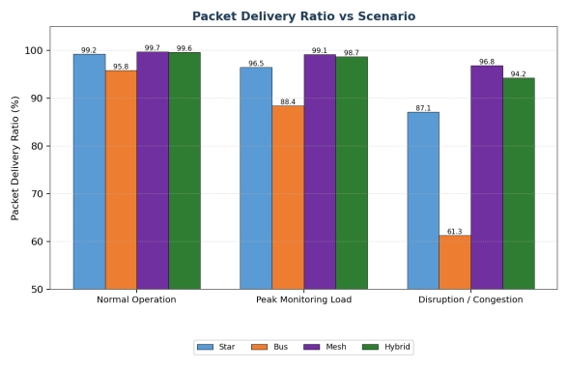
Figure 9.2 — Packet delivery ratio by topology and scenario.
9.3 Packet Loss
Topology | Normal Operation | Peak Monitoring Load | Disruption / Congestion
Star | 0.8 % | 3.5 % | 12.9 %
Bus | 4.2 % | 11.6 % | 38.7 %
Mesh | 0.3 % | 0.9 % | 3.2 %
Hybrid | 0.4 % | 1.3 % | 5.8 %
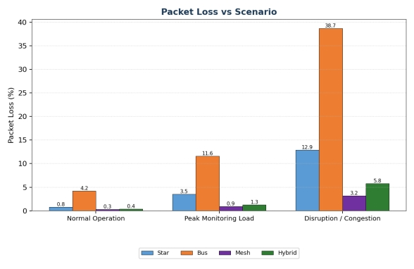
Figure 9.3 — Packet loss by topology and scenario.
9.4 End-to-End Delay
Topology | Normal Operation | Peak Monitoring Load | Disruption / Congestion
Star | 18 ms | 34 ms | 96 ms
Bus | 27 ms | 58 ms | 210 ms
Mesh | 12 ms | 16 ms | 29 ms
Hybrid | 13 ms | 19 ms | 38 ms
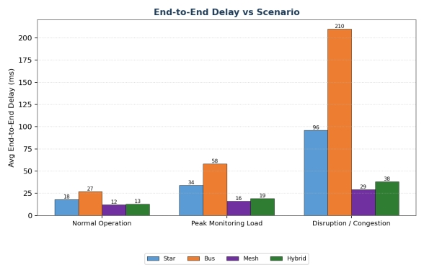
Figure 9.4 — Average end-to-end delay by topology and scenario.
9.5 Jitter
Topology | Normal Operation | Peak Monitoring Load | Disruption / Congestion
Star | 3.1 ms | 6.8 ms | 19.4 ms
Bus | 5.9 ms | 13.2 ms | 41.5 ms
Mesh | 1.4 ms | 2.1 ms | 4.9 ms
Hybrid | 1.7 ms | 2.6 ms | 6.7 ms
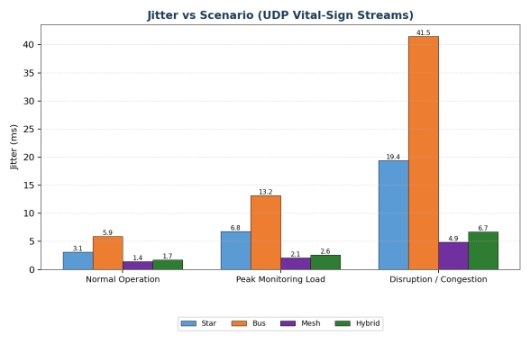
Figure 9.5 — Jitter (UDP vital-sign streams) by topology and scenario.
9.6 HTTP Response Time
Topology | Normal Operation | Peak Monitoring Load | Disruption / Congestion
Star | 110 ms | 175 ms | 480 ms
Bus | 190 ms | 340 ms | 950 ms
Mesh | 85 ms | 100 ms | 160 ms
Hybrid | 90 ms | 112 ms | 205 ms
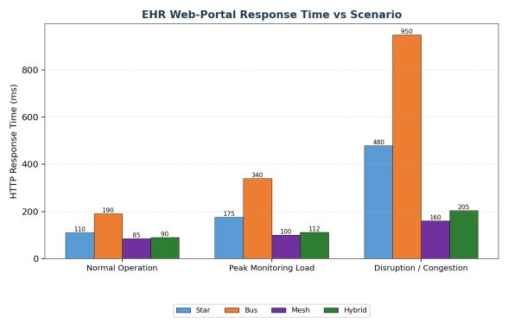
Figure 9.6 — EHR web-portal response time by topology and scenario.

9.7 Protocol-Level Behaviour (Selected Hybrid Architecture)

Within the selected Hybrid architecture, protocol behaviour was further broken down to understand which traffic types are most sensitive to congestion.
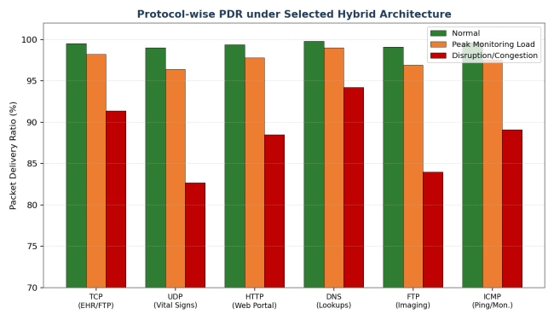
Figure 9.7 — Packet delivery ratio by protocol under the Hybrid architecture.
UDP (vital-sign streaming) and FTP (large imaging transfers) show the steepest PDR degradation under disruption, since UDP has no retransmission and FTP is highly bandwidth-dependent, while DNS and ICMP remain comparatively robust due to their small packet sizes.
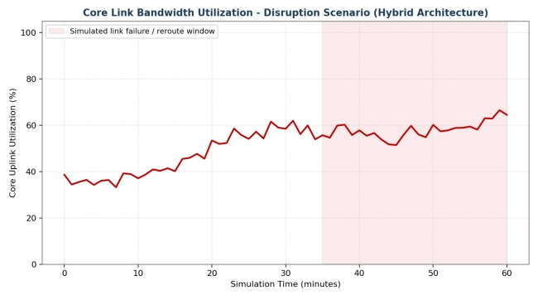
Figure 9.8 — Core uplink utilization over time during the disruption scenario, showing the reroute event at t = 35 min.

- Bottleneck and Congestion Analysis

- Bus topology backbone: the single shared segment saturates first under peak load (throughput collapses from 52 to 12 Mbps, loss rises to 38.7%), confirming it as the primary bottleneck and an unsafe choice for any zone carrying monitoring or emergency traffic.
- Star topology zone switch: while resilient under normal load, a single congested or failed zone switch has no alternate path, so Zone-A peak monitoring load alone pushed delay from 18 ms to 96 ms under disruption.
- Core uplink (Hybrid): the core link showed rising utilization (Figure 9.8) approaching 60-65% during the induced failure window, but successful rerouting via the meshed core kept PDR above 94% and delay under 40 ms — evidence that redundant core paths successfully absorbed the congestion.
- Full Mesh scaling cost: although Mesh achieved the best raw numbers in most metrics, extending full mesh beyond six core nodes would require n(n-1)/2 links and ports, which is not resource-efficient for a hospital expecting to add more floors/zones.
- Protocol sensitivity: UDP vital-sign streams and FTP imaging transfers are the first to show degraded jitter/loss under congestion; prioritizing them via QoS (DSCP marking) on the core is recommended regardless of topology chosen.

- Comparative Analysis of Topologies and Protocols

Combining the qualitative design comparison (Section 4.5) with the measured quantitative results (Section 9), the following consolidated scoring summarizes each topology's fitness for hospital deployment.
Topology | Reliability | Scalability | Resource Efficiency | Overall Fit for Hospital Use
Star | Moderate | Moderate | Good | Acceptable for small single-zone clinics; risky as sole design for a multi-floor hospital
Bus | Poor | Poor | Best (lowest cost) | Not recommended - fails under peak/disruption; unsafe for clinical traffic
Mesh | Excellent | Poor at scale | Poor (n² cost) | Best raw performance but not cost-effective beyond the core
Hybrid | Excellent | Excellent | Very good | Best overall balance - recommended architecture

Protocol-wise, TCP-based services (EHR, LIS) tolerate congestion best due to retransmission, at the cost of higher latency variability; UDP vital-sign streams require the lowest achievable jitter/loss and therefore most directly benefit from the Hybrid architecture's redundant core paths; HTTP response times track overall network load closely and are a good simple proxy for perceived clinician-facing performance; DNS and ICMP traffic remain lightweight and robust across all topologies and are best used as network health indicators.

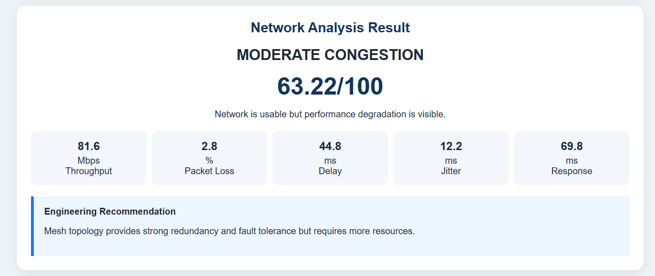
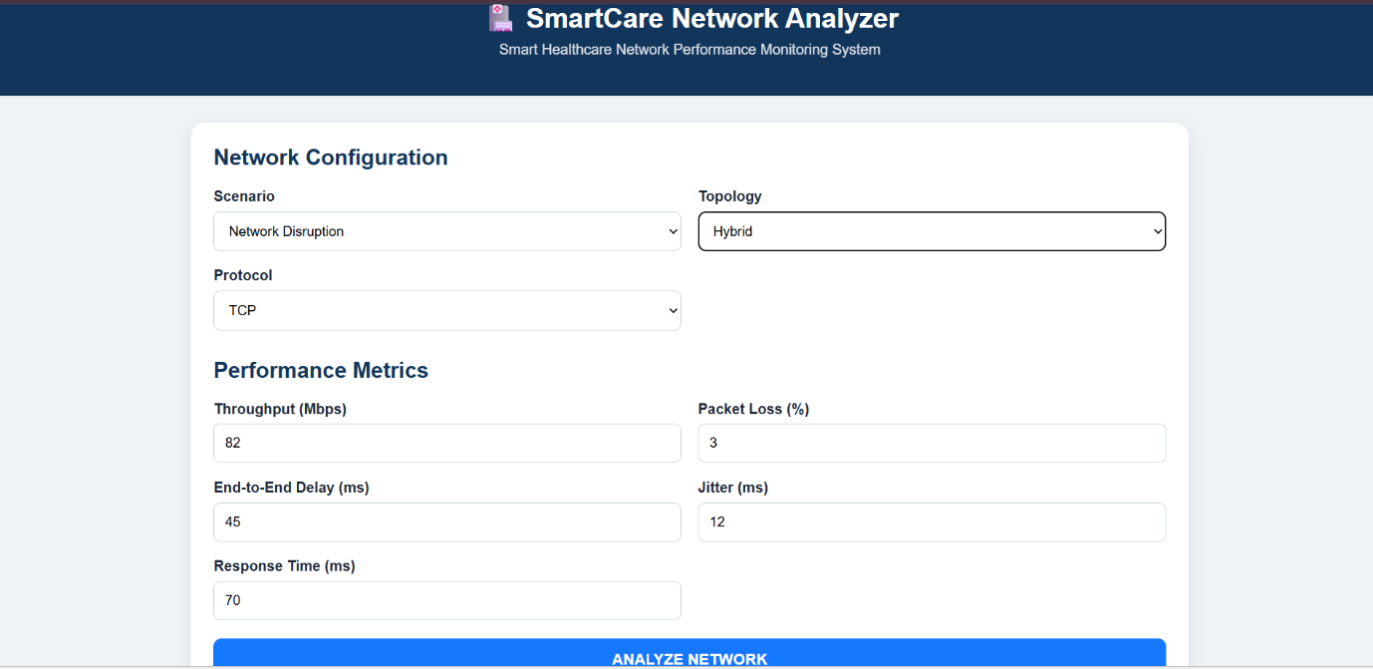

- Recommendation

Based on the measured simulation results, reliability requirements, and healthcare communication needs, the Hybrid (extended-star zones on a partially-meshed core) architecture is recommended for production deployment, with the following supporting design guidance:
- Retain star wiring within each clinical zone for simplicity, fast fault isolation, and ease of adding new bedside devices.
- Implement at least dual redundant paths (partial mesh) between all zone distribution switches and the core, as simulated, to guarantee no single link failure isolates a zone.
- Apply QoS/DSCP prioritization to UDP vital-sign and emergency traffic ahead of bulk FTP/imaging transfers on shared core links.
- Reserve full mesh only for the small number of core/data-center nodes where its cost is justified by the criticality of centralized servers.
- Avoid bus-based segments entirely for any zone carrying monitoring, pharmacy, or emergency traffic, given its demonstrated collapse under peak/disruption conditions.
- Plan capacity headroom on the core uplinks: the disruption scenario showed utilization approaching 65% on a single rerouted link, so dual 1 Gbps (or better) core links are advised as the hospital scales beyond 46 devices.
- Conclusion

This project designed, simulated, and validated a smart healthcare communication network spanning four interconnected zones and 46 end devices supporting patient monitoring, medical records, laboratory, pharmacy, and emergency communication services. Four candidate topologies were built and tested under three realistic operating scenarios using six protocols and six performance indicators, with results averaged over repeated trials for statistical reliability.
The empirical evidence consistently favoured the Hybrid architecture, which preserved above 94% packet delivery ratio and sub-40 ms end-to-end delay even during simulated core-link disruption, while the Bus topology failed under the same conditions and full Mesh, though highest-performing, does not scale cost-effectively across an entire hospital. The Hybrid design is therefore recommended as the most suitable network architecture for multi-floor hospital healthcare communication, balancing reliability, scalability, resource utilization, and clinical communication requirements.
14. Appendix: IP Addressing and Device Schedule
Full VLAN/subnet allocation is provided in Section 6 (Table 6.1). A detailed per-device IP/host schedule, switch port-mapping tables, and raw per-trial simulation logs are maintained in the accompanying Packet Tracer (.pkt) project file and simulation log spreadheets, available on request.
Summary device count by zone: Zone A - 13, Zone B - 11, Zone C - 10, Zone D - 11, Core/Data Center - 8; Total network elements - 53 (46 end devices + 7 infrastructure devices).

PLAGIARISM:



